TASK 2

Three phase motor connected to full-voltage magnetic starter controlled by stop and start push button station with indicating light's ss stop (idle) and start (rmn).

Power Circuit

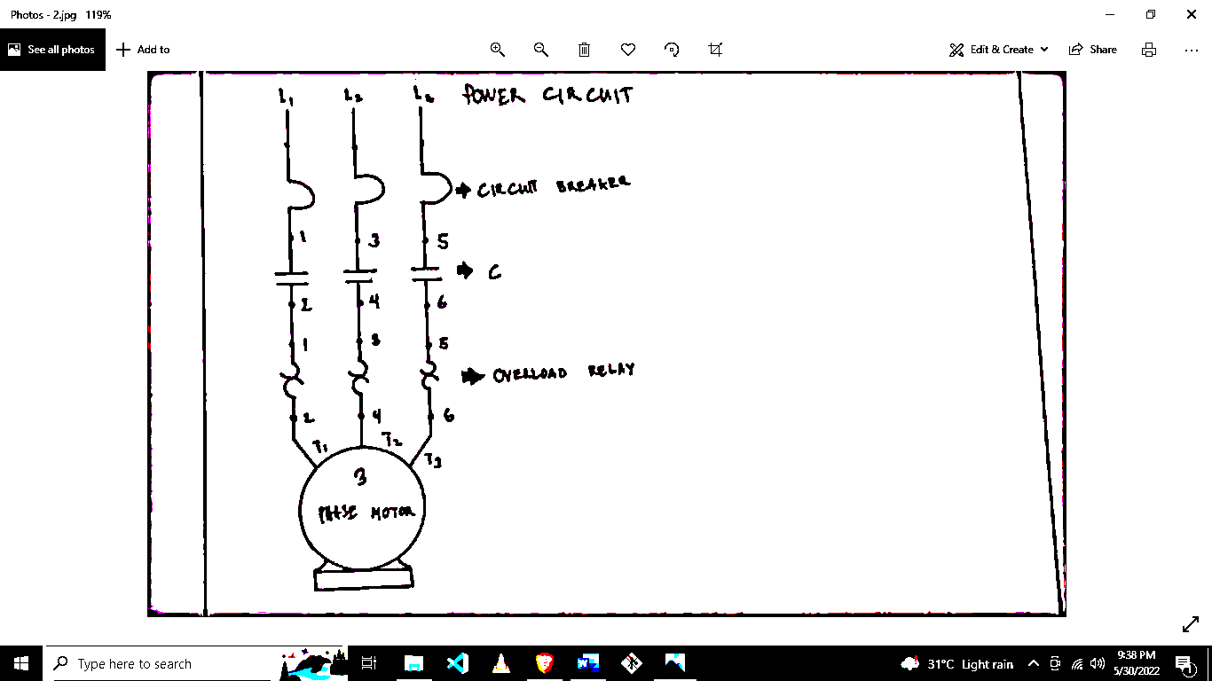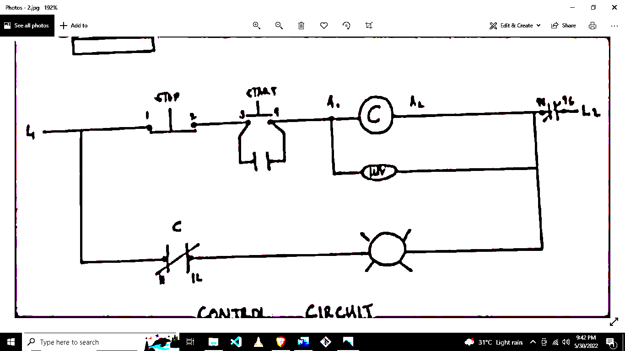

Overload Relay

C

Circuit Breaker

Control Circuit

Checked By:

Rudy C. Docoy

SSCT SURIGAO CITY

TASK #

MOTOR CONTROL

**Date :**May 31, 2022

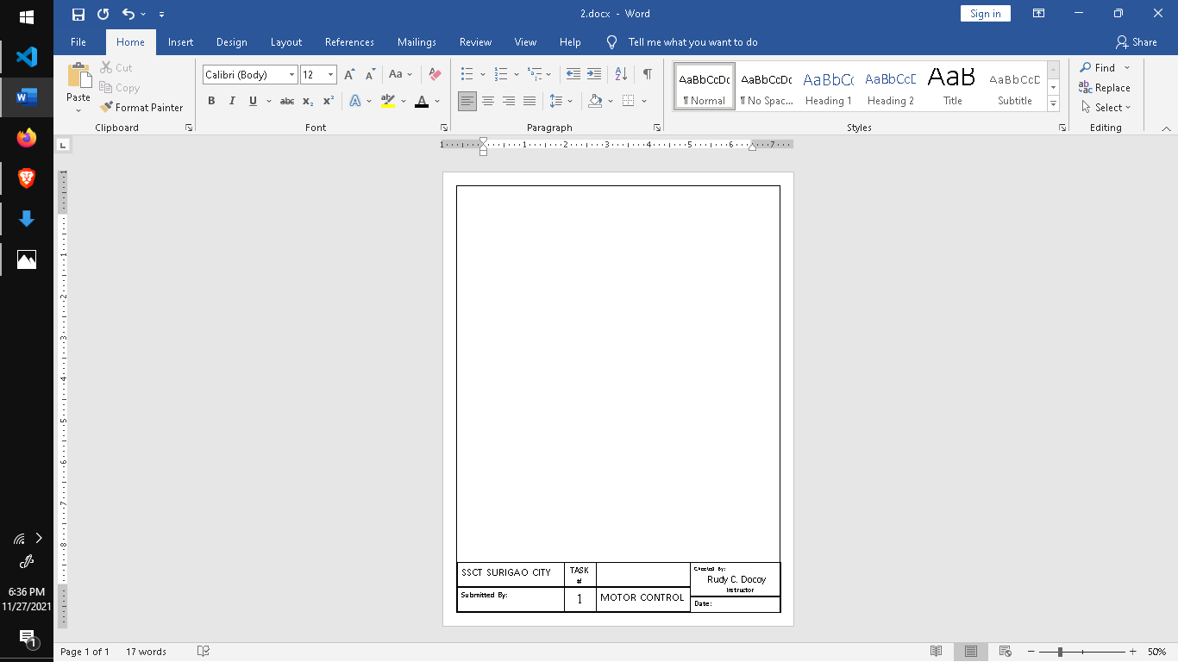

Instructor



2

Submitted By:

BEET 3C